*Buy or Sell? An Expert’s Take On How Investors Should Deal With The Disappointment of the MSNAI Stock*

The firm Mediocre Social Network Apps Incorporated (MSNAI) has been taking a hit for the last few years. It has been on a steady decline since the beginning of 2015, but, on occasion, has experienced short-term rebound returns. The following is a time series of the stock price.

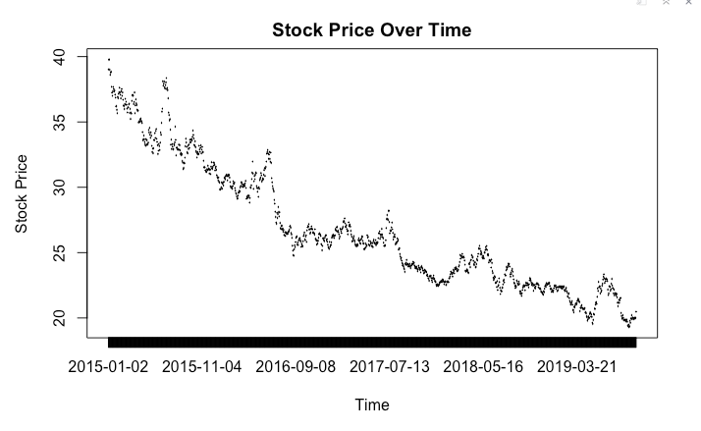

With investors perplexed on whether or not to drop the stock or buy more at a low before it bounces back again, my team of top-notch analysts decided to conduct a time series analysis in an attempt to forecast the stock prices for the next 10 days as we roll into October of the year 2019.

At first glance, one might be brave enough to attempt to generate what statistians call “a deterministic model” of the data. This would be the model that describes the underlying pattern the stock prices follow, with any deviation from this pattern being “noise”, or random natural variation. Here is the plot from the determinsitic model our expert analysts were able to generate.

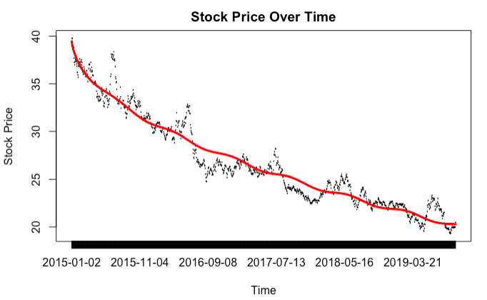

As one can see, our analyst were able to capture the relative trend of the data quite well, but unfortunately were not able to capture the “seasonality”, or what the layman would call “bumps” in the data. The lead analyst on the team says that these bumps in the data are not consistantly spaced throughout the timeseries, and therefore one cannot obtain a determinstic model on the data.

But no fear! Our analysts are so smart they were able to come up with another model that could be used for forecasting! They call this an AR(4) model, and, of all the models tested, the AR(4) model was best able to predict in-sample data points. The analysts used a metric called MSE, which stands for mean squared error, and calculates the squared difference between the predicted stock prices and the actual stock prices. Using a fancy technique called cross-validation, the analysts determined that the AR(4) model would be best for predicting out of sample data points (in this case, the stock prices for the next 10 days).

So they ran the model on all the data they had on the MSNAI stock and forecasted the stock prices for the next 10 days. Here is what they got:

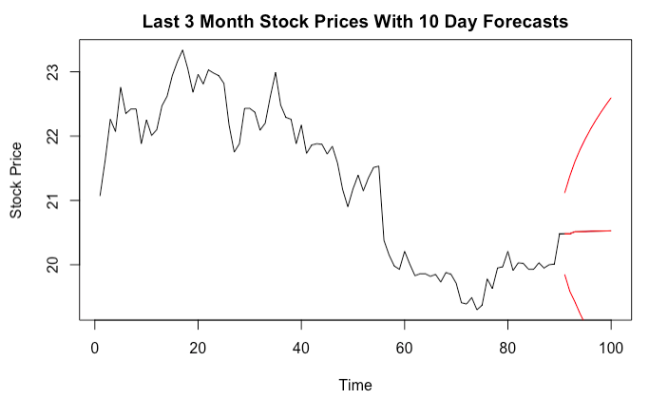

Here, the fairly straight horizontal line respresents the forecasted stock prices, and the two red lines sticking out from either side represent the room for possible error. As one can see, the stock price is expected to increase ever so slightly in the next 10 days. However, there is a relatively huge amount of potential error. So even though we expect the stock price to go up, there is also a pretty decent chance the stock will go down as well.

For this reason, it is probably a good idea for short-term investors to hold on to the stock for the next 10 days, as there is not enough evidence to suggest that buying more would be profitable. In fact, given the overall trend of the data, our team of analysts would recommend long-term stock holders to sell now (or even short the stock), as the stock is likely to keep on the declining path in the long-run.

Stay classy investors. We’ll see you again next week.